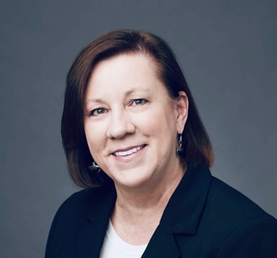

Karen J. Solomon joined the Higher Learning Commission in 2003 and serves as Vice President for Accreditation Relations and Director of the Standard Pathway. Since 2016, she has been leading HLC’s future-focused grant initiatives on innovation and student success.
Dr. Solomon presently serves as a public representative for the Council for the Advancement of Standards in Higher Education (CAS) and is a past chair of the WCET Executive Council.
Previously, Dr. Solomon was the founding Executive Director of Illinois Campus Compact and served in various roles at ACT, Inc and higher education institutions. She holds an Ed.D. in Adult and Continuing Education from Northern Illinois University with a focus on adult learners and educational technology.

