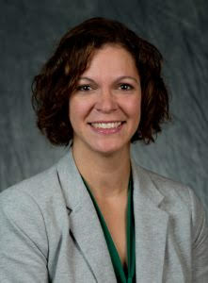
Natasha Jankowski
Dr. Natasha Jankowski is the former Executive Director of the National Institute for Learning Outcomes Assessment (NILOA). Dr. Jankowski currently serves as a higher education and assessment consultant as well as a lecturer with New England College. She is co-author of the books Using Evidence of Student Learning to Improve Higher Education; the book Degrees that Matter: Moving Higher Education to a Learning Systems Paradigm, and the edited volume Student-Focused Learning and Assessment: Involving Students in the Learning Process in Higher Education. A forthcoming book focuses on equity and assessment. Her areas of interest include assignment design, transparency, evidence-based storytelling, equity, mapping and alignment of learning, and all things assessment. Natasha is the recipient of the Kent State University’s Alumni Award and the Young Alumni Award from the University of Illinois Urbana-Champaign. Under her leadership, NILOA was the proud recipient of the ACPA Contribution to Higher Education award. She holds a Ph.D. in Higher Education from the University of Illinois, an M.A. in Higher Education Administration from Kent State University, and a B.A. in philosophy from Illinois State University.

